**ASSIGNMENT 4**

**PART A**

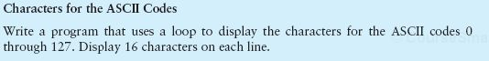

for (int i=0; i<=127; i++)

{ cout << char(i) << “ ”;

if (i % 16 == 0)

cout<< endl;}

**PART B**

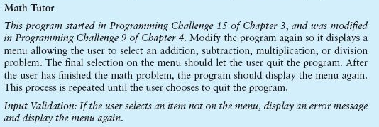

**PART C**

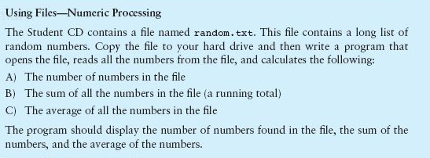

HINT for PART C: You do not need to declare variables for each single number in the file.

You need only one variable to read a number, process it ( add it to the sum ) and then reuse

that same variable to read the next number.